Reviewing an Assignment
Once a user has completed an assignment, what's next? This article covers how to review an assignment from the admin area. If the student shared an external link, you can follow the same steps outlined in this support article.
Step 1: Go to the "Assignments" tab and locate your assignment.
Step 2: Click the assignment name to view a list of users who have completed the assignment. Click on "Review Now" to begin reviewing. 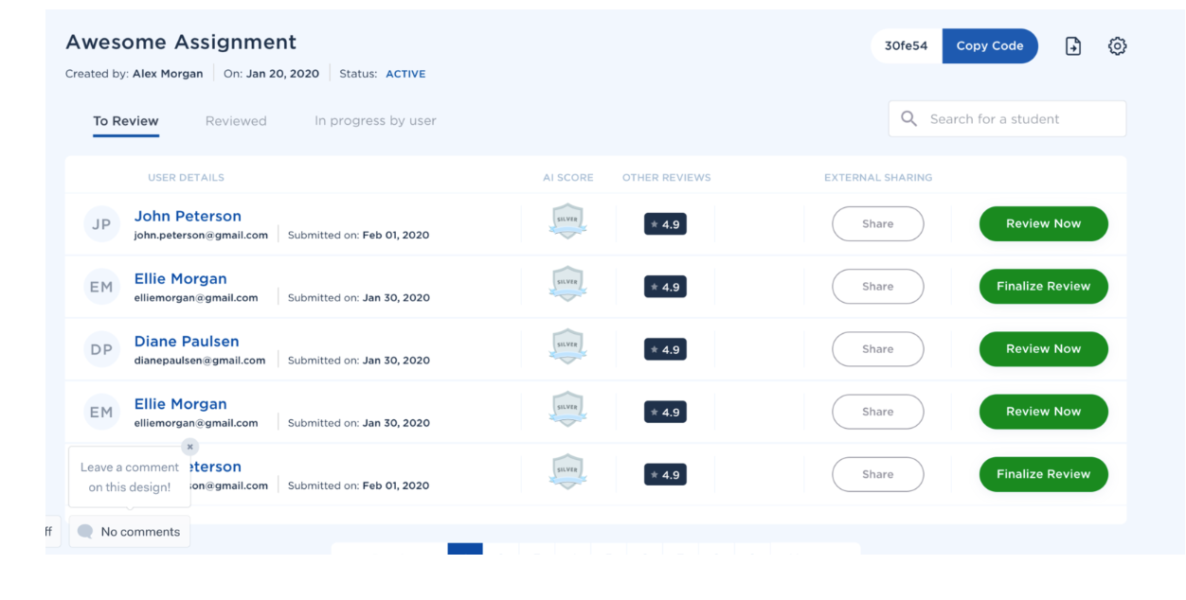
Step 3: You can now review each video or review the entire assignment. To review individual videos,click "Review Answer", complete your review, and then click "Save Review & Continue".
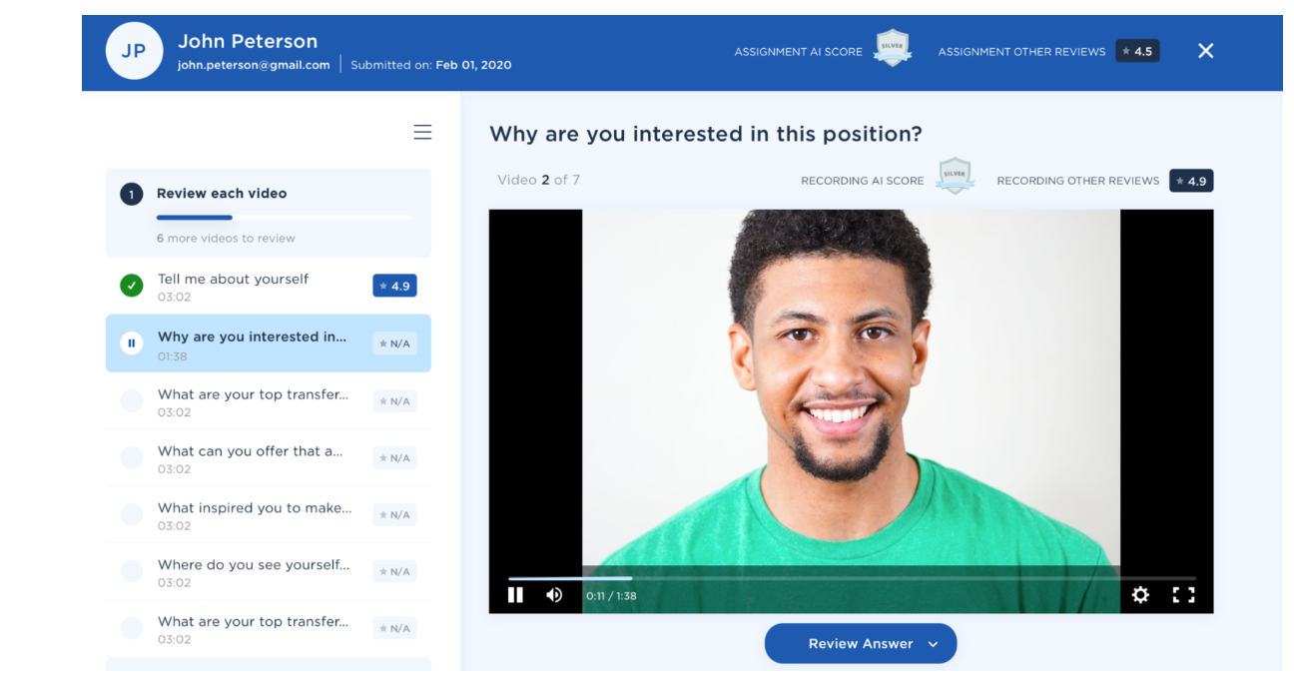
Step 4: To review the entire assignment, click "Review entire assignment", complete your review, and click "Save Review & Finalize".
